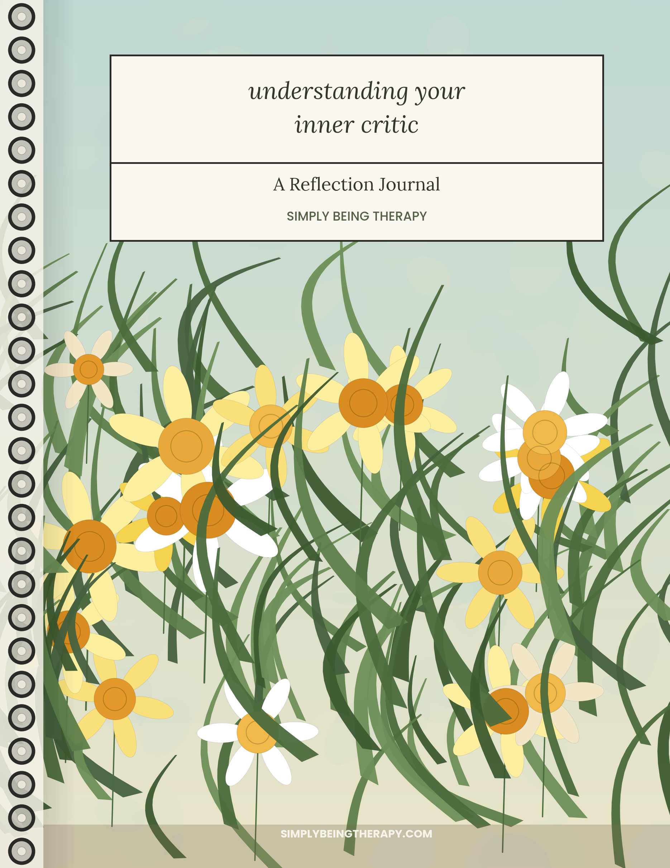

BEFORE WE BEGIN

Welcome

I want to tell you something before we begin, because I think it matters more than anything else in this workbook: you are not broken, and the voice you're about to spend some time with is not evidence that something is wrong with you.
Most people come to this subject already tired. Tired of the internal commentary that shows up after a mistake, or before a risk, or in the quiet minutes before sleep. Tired of trying to think their way out of it. If that's you, I'd like to offer a different starting place. Instead of asking how to silence this voice, we're going to get curious about it — where it came from, what it's trying to do, and what it might need in order to loosen its grip a little.
This isn't a workbook you'll finish and then feel entirely different. It's closer to a conversation, the kind you might have in a therapy room, where understanding builds slowly and in layers. You'll come back to one real moment from your life several times over these pages, looking at it from a few different angles. By the end, my hope isn't that you'll have “learned about the inner critic.” It's that you'll understand something new about yourself.
Take your time. There's no version of this that you can do wrong.

Dr. Barbie Hessel, LCSW, SEP, CPATP, SP
Founder and Psychotherapist
SIMPLY BEING THERAPY

BEFORE WE BEGIN

How to Use This Workbook

A few notes before you start.
Choose one situation, and stay with it. Early on, I'll ask you to think of a recent moment when you were especially hard on yourself. Try to pick something real and specific rather than a general pattern — an email you sent, a conversation that went sideways, a mistake at work, a moment with your kids you wish you could redo. You'll return to this same moment throughout the workbook. That repetition is intentional. Each chapter will ask you to look at it slightly differently, the way a good therapist might return to something you mentioned in session three when you're sitting together in session nine.
You'll see the same four sections in every chapter. A Therapist's Reflection offers a small piece of what I might say to you if we were in a room together. A Research Snapshot summarizes relevant psychological research in plain language, without jargon. Pause & Reflect is a moment to slow down mid-chapter. Take It With You closes each chapter with something to carry into your week.
This isn't a test. There's a workbook page after every chapter of reading. Some parts ask you to write, some ask you to circle or rate or check a box. Use whichever format helps you think. If a question doesn't fit your experience, skip it or change it to fit.
A CAVEAT
This workbook draws on ideas from Internal Family Systems therapy, self-compassion research, and somatic psychotherapy. It's meant to be a reflective, educational resource — not a substitute for therapy, and not a diagnostic or clinical tool. If working through this brings up more than you expected, that's worth mentioning to a therapist, not something to push through alone.

CHAPTER 1

Meeting Your Inner Critic

Almost everyone has a version of this voice. It might sound like a harsh parent, a disappointed teacher, or simply your own thoughts turning sharp. It tends to show up in predictable places — after a mistake, before something important, in the space between what you did and what you think you should have done. Some people hear it constantly, in a low hum underneath everything. Others only notice it in certain situations: at work, in relationships, around their bodies, around money.
I want to start somewhere unusual. Instead of asking what your inner critic says, I want to ask what it's like to have one. Is it more like a voice, or more like a feeling — a tightness, a bracing, a familiar dread? Does it use words at all, or is it closer to an atmosphere that settles over you? People describe this differently, and there's no more correct way to experience it.
Here's something I've noticed after years of sitting with people in this exact spot: the inner critic almost never announces itself as an enemy. It usually believes it's helping. It thinks that if it points out your flaws first, loudly enough, no one else will get the chance to be more cruel about them. It thinks that if it keeps you small, you won't risk the bigger disappointment of failing in public. It thinks that if it keeps pushing, you'll finally be enough, and then — only then — it can rest. This doesn't make the voice pleasant to live with. But it does change what we're dealing with. We're not trying to defeat an enemy. We're trying to understand a part of you that has been working very hard, for a very long time, at a job it was never quite equipped to do well.
In Internal Family Systems, a model of therapy developed by Richard Schwartz, this idea has a specific shape. IFS suggests that the mind isn't a single, unified thing, but is made up of different “parts” — distinct, dynamic aspects of a person's inner world, each with its own perspective, feelings, and role. Some parts carry pain from earlier in life. Others develop specifically to protect against that pain — these are often called managers, parts that try to keep things controlled, orderly, and safe by staying one step ahead of criticism, failure, or rejection. An inner critic frequently functions as a manager part. Not always, and not for everyone — people and their inner lives are more varied than any single framework can fully capture — but often enough that it's worth considering here. If this idea resonates with your own experience, we'll explore it further. If it doesn't quite fit, trust what you notice instead.
This reframing matters because of what it makes possible. If the inner critic is simply a flaw in you, the only options are to suppress it or be ruled by it. But if it's a part of you that took on a protective job — likely a long time ago, likely without much choice in the matter — then a third option opens up. You can turn toward it instead of away from it. You can ask it questions instead of only receiving its verdicts. That shift, from being run by a part to being in relationship with it, is where almost everything in this workbook is heading.
We're going to move slowly. This chapter simply asks you to notice — to bring one real, recent situation into focus and observe, without yet trying to fix or explain, what your inner critic said and how it felt to hear it.

THERAPIST'S REFLECTION
I think of the inner critic as something closer to an overzealous employee than a villain — someone who was hired for a real job a long time ago and never received an updated job description. It's still showing up for work every day. The problem isn't its dedication. It's that no one has told it the job has changed.

RESEARCH SNAPSHOT
Self-criticism is consistently linked to higher rates of anxiety and depression, while self-compassion is associated with greater emotional resilience and psychological well-being. Researchers including Kristin Neff have found that people who relate to their own suffering with more warmth — rather than more judgment — tend to recover from setbacks more quickly, not less quickly. Self-kindness doesn't appear to reduce motivation. In study after study, it supports it.

WORKBOOK
MEETING YOUR INNER CRITIC
1 Bring one situation to mind.
Choose a recent moment when you were especially hard on yourself. You'll return to this same situation throughout the workbook, so pick something specific and real.

2 What did your inner critic actually say?
Try to recall its exact words, as closely as you can.

3 What tone did it use?
Circle all that apply.
Harsh · Cold · Panicked · Disappointed · Exhausted · Mocking · Flat · Urgent · Familiar
4 Circle the emotions you noticed in that moment.
Shame · Anger · Fear · Sadness · Numbness · Anxiety · Relief · Loneliness · Embarrassment
5 Rate how intense the experience felt.
Mild 1 — 2 — 3 — 4 — 5 — 6 — 7 — 8 — 9 — 10 Overwhelming
6 Where did you notice it in your body, if anywhere?
☐ Chest ☐ Throat ☐ Stomach ☐ Shoulders ☐ Jaw ☐ Hands ☐ Not sure
7 If your inner critic had a job title, what would it be?

8 What do you notice now, just from having written this down?


TAKE IT WITH YOU
This week, if your inner critic shows up, try simply naming it — “There it is” — without needing to argue with it or obey it yet. Naming is its own small act of separation.

CHAPTER 2

What Is This Part Trying to Protect?

Let's go back to the situation you described. Not to relive it, but to look at it from a different vantage point — the way a therapist might ask, weeks later, “What do you think that part of you was actually trying to do in that moment?”
It's a strange question at first, because when the inner critic is loud, it doesn't feel protective. It feels like an attack. But protection and harshness aren't opposites — plenty of protection is harsh. A parent who grabs a child's arm before they step into traffic isn't being gentle, and the child may only feel the grab, not the danger it prevented. Something similar can happen internally. A part of you may be bracing against a danger you can no longer fully see, using the only strategy it has ever known: get there first, be harder on you than anyone else could be, and maybe the blow will land softer.
What is it actually guarding against? This is different for everyone, but a few patterns show up often. Some inner critics are trying to prevent the shame of visible failure — if you criticize yourself first, a mistake feels less like an exposure and more like something you already knew. Some are trying to preempt rejection — if you point out your flaws before anyone else can, it feels a little more survivable than being caught off guard by someone else's judgment. Some are guarding old wounds around not being enough, keeping you striving so that the ache of inadequacy stays at a manageable distance. And some are simply trying to keep you safe in a more literal sense — pushing you toward competence and vigilance because, at some point, competence and vigilance were the things that kept you out of harm's way.
None of this requires you to have had a dramatic history. Protective parts form in response to ordinary things too — a home where mistakes drew a parent's disappointment, a classroom where being wrong felt public and humiliating, a family that only noticed you when you achieved something. Small repeated moments can shape a part just as thoroughly as one large one.
I want to be careful here, because this is a place people often misuse the idea. Understanding your inner critic as protective doesn't mean thanking it and moving on, and it doesn't mean the pain it causes is somehow fine because it means well. It also doesn't mean every harsh thought is a manager part in the IFS sense, or that this framework explains everything about your particular history — sometimes a hard moment is just a hard moment. What we're doing instead is getting more precise: separating the strategy the part is using from the intention underneath it, so that eventually you can address the intention directly, without needing the same old strategy to keep running.

THERAPIST'S REFLECTION
When clients ask me, “But why would any part of me want to hurt me like this?” I usually say: I don't think it does. I think it's trying to prevent a bigger hurt using the only tool it was ever given. That doesn't make the tool a good one. It just means the goal, underneath the noise, might be worth taking seriously.

RESEARCH SNAPSHOT
IFS theory proposes that protective parts, sometimes called managers, take on preemptive roles — trying to control situations and internal experience before more vulnerable feelings can surface. While IFS is an evolving clinical model rather than a settled scientific consensus, its central claim — that harsh self-talk often functions as an attempt at protection rather than pure self-sabotage — is echoed in broader psychological research on self-criticism as a (misguided) emotion-regulation strategy.

WORKBOOK
WHAT IS THIS PART TRYING TO PROTECT?
1 Return to your situation.
In one sentence, remind yourself what happened.

2 What do you think this part was trying to protect you from?
Circle any that fit; add your own.
Embarrassment · Rejection · Failing publicly · Disappointing someone · Being “found out” · Getting hurt again · Losing control

3 If this part could talk about its intentions, not just its insults, what might it say?
Example: “If I don't say it first, someone else will say it worse.”

4 Has this part ever actually helped you — even if the method was harsh?
☐ Yes ☐ No ☐ Not sure
If yes, how?

5 What is this strategy costing you now?

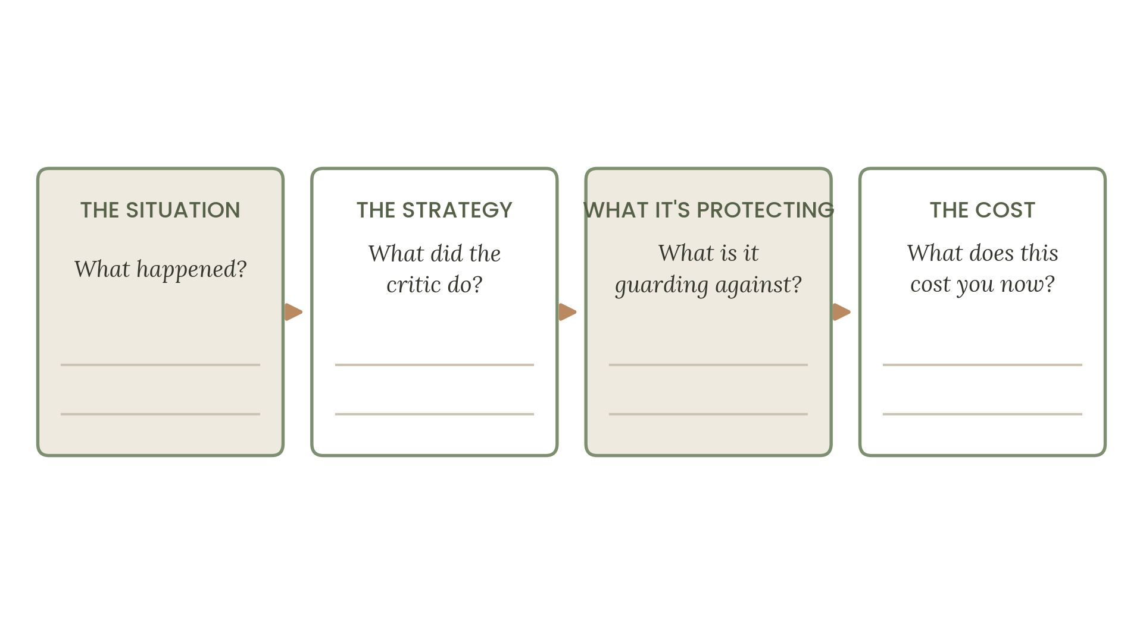
6 Complete this sentence:
“I think this part is trying to keep me safe from _______________________, and it's using _______________________ to do it.”
PAUSE & REFLECT
Before moving on, take three slower breaths. Notice if anything shifts in your body as you consider that this voice might be protective rather than purely cruel. You don't have to believe it fully yet. Just notice what it's like to consider it.
TAKE IT WITH YOU
This week, if the critic appears, try asking it silently: “What are you afraid would happen if you stopped?” You don't need an answer right away. The question itself starts to change the relationship.

CHAPTER 3

Where Did This Voice Learn Its Job?

Every protective part had to learn its strategy from somewhere. No one is born believing that self-attack is the safest response to a mistake. That belief is built, usually in childhood, out of the messages that were available at the time — spoken directly, or absorbed simply by watching what got rewarded and what got punished.
Let's go back once more to your situation, but this time, listen for an echo. When your inner critic spoke, whose voice did it resemble? For many people, it's a parent's voice, exactly as remembered, word for word. For others, it's less a specific person and more a composite — a blend of a teacher's disappointment, a sibling's comparison, a cultural message about who is allowed to struggle and who isn't. Some people don't hear a specific person at all, but a tone: clipped, exasperated, already certain of the worst.
This isn't about assigning blame to the people in your past, and it isn't about deciding your family did something wrong. Most people who raise children pass along messages they never examined, often ones they received themselves and never had the chance to question. A parent who was raised to believe mistakes were dangerous will likely teach vigilance around mistakes, not out of unkindness, but because that's the map they were handed. Understanding where a message came from isn't the same as blaming its source. It's simply a way of loosening the message's grip — recognizing it as something you learned, rather than something permanently true about you.
Consider the different domains where these early messages take root: mistakes, emotions, asking for help, achievement, worth. What did you learn, growing up, about what happens when you get something wrong? What did you learn about showing sadness, or fear, or anger — was there room for those feelings, or did they need to be managed quickly and privately? What did you learn about needing help — was it met with support, or did it seem to register as weakness or inconvenience? What did achievement seem to earn you — attention, safety, love — and what happened in its absence? And underneath all of it: what did you learn, implicitly, about whether your worth was something inherent, or something to be proven again and again?
These questions aren't meant to produce a tidy origin story. Most people's histories are more tangled than that — a parent who was warm in some ways and exacting in others, a school that praised effort in theory and results in practice. The goal isn't a clean narrative. It's simply noticing that this voice had a beginning. It was taught. And most things that are taught can, with real effort and often real support, eventually be taught differently.

THERAPIST'S REFLECTION
I sometimes ask clients, “If you closed your eyes and let your inner critic speak in full sentences, whose voice would you hear?” Almost everyone can answer immediately, which tells me something: this voice isn't randomly generated by your brain. It was handed to you. And anything that was handed to you can, eventually, be handed back.

RESEARCH SNAPSHOT
Research on early attachment and internalized criticism suggests that the tone children absorb from caregivers — critical, anxious, warm, dismissive — often becomes the tone people later use with themselves. This isn't destiny. Studies on self-compassion training show that adults can shift these internalized patterns over time, particularly through deliberate practices that build a different, kinder internal voice alongside the old one, rather than trying to erase it outright.

WORKBOOK
WHERE DID THIS VOICE LEARN ITS JOB?
1 Whose voice does your inner critic resemble?
A parent, teacher, sibling, culture, or “no one in particular” are all valid answers.

2 What did you learn, growing up, about each of these?
Jot a word or short phrase for each.
Mistakes: _______________________
Emotions: _______________________
Asking for help: _______________________
Achievement: _______________________
Your worth, in general: _______________________
3 Which of these messages do you still hear echoed in your inner critic today?

4 Rate how strongly this voice resembles a specific person from your past.
Not at all 1 — 2 — 3 — 4 — 5 Almost exactly
5 If this belief was taught rather than simply true, what might that change?

PAUSE & REFLECT
Notice if this chapter brought up tenderness, grief, anger, or something else entirely toward the people who shaped this voice. All of those responses make sense. None of them need to be resolved today.
TAKE IT WITH YOU
This week, when the critic speaks, try silently noting: “This sounds like a message I learned, not a fact about who I am.” You don't have to fully believe it. Just let the sentence sit alongside the old one.

CHAPTER 4

Listening to Your Body

So far, we've mostly stayed in the realm of thought — words, messages, origins. But the inner critic rarely lives only in language. It has a body, too, or at least a body it moves through: yours.
Think back, once more, to your situation. Before you even knew what your inner critic was going to say, something likely happened physically. Maybe your chest tightened, or your stomach dropped, or your shoulders crept toward your ears. Maybe your breath got shorter and higher in your chest without your noticing. These sensations often arrive a half-second before the words do, which is worth sitting with: your body may register the threat before your mind has finished narrating it.
This is where somatic psychotherapy offers something useful. Rather than trying to think your way past self-criticism, somatic approaches suggest working with the body directly — noticing sensation, orienting to the present environment, and using breath as an anchor back into the here and now. I want to be precise about the science here, because this area attracts a lot of overstatement: it is not accurate to say trauma is simply “stored” in muscles or tissue as though it were an object tucked away somewhere. What the evidence does support is narrower and still meaningful — the nervous system responds to perceived threat with real physiological changes, and body-based practices like grounding, orienting, and breath awareness can help shift the nervous system out of a state of alarm and into one where reflection becomes more possible.
Grounding simply means bringing attention to points of physical contact — your feet on the floor, your back against a chair — to remind the nervous system that you are here, now, and not in the remembered moment. Orienting means slowly looking around the room you're actually in, letting your eyes land on specific objects, giving your brain concrete, present information rather than letting it stay looped in a memory. Breath awareness means noticing your breath without necessarily changing it at first, and then, if it helps, lengthening the exhale slightly, which tends to have a calming effect on the body.
None of this is about bypassing the emotional content of the moment. It's about widening the space around it, just slightly, so you have more room to respond rather than simply react. A nervous system on high alert doesn't have much access to nuance, curiosity, or self-compassion — those capacities tend to come back online once a person feels even a little more physically settled. This is often why purely cognitive strategies — trying to argue with the inner critic using logic alone — can fall flat in the heat of the moment. The body needs to be part of the conversation too.

THERAPIST'S REFLECTION
I've had clients tell me, almost apologetically, “I know logically that I'm fine, but my body won't believe it.” I always tell them that's not a contradiction — that's exactly how it works. The body often needs its own kind of reassurance, delivered in its own language, before the mind's reassurance can actually land.

RESEARCH SNAPSHOT
Research on the autonomic nervous system shows that perceived threat activates physiological stress responses — a racing heart, shallow breathing, muscle tension — largely outside conscious control. Practices such as slow, extended exhales and grounding through the senses have been shown to support a shift from a sympathetic, “on alert” state toward a calmer, more regulated one, making space for the kind of reflective thinking that harsh self-talk tends to crowd out.

WORKBOOK
LISTENING TO YOUR BODY
1 Return to your situation once more.
Close your eyes if that's comfortable, and notice: where did you feel it first, in your body?

2 Describe the sensation, if you can.
Circle any that fit.
Tight · Hot · Cold · Heavy · Fluttery · Numb · Tingling · Shaky · Frozen
3 Try this now:
Place both feet flat on the floor. Notice the contact. Slowly look around the room and name three things you see.

4 Take four slow breaths, making the exhale slightly longer than the inhale.
What do you notice now, compared to before?

5 Rate your body's sense of alarm right now, in this moment.
Calm 1 — 2 — 3 — 4 — 5 — 6 — 7 — 8 — 9 — 10 On high alert
6 What helps you feel even slightly more grounded, in general?
☐ Feet on the floor ☐ Slower breathing ☐ Cold water ☐ Movement ☐ A specific person's voice ☐ Naming what I see
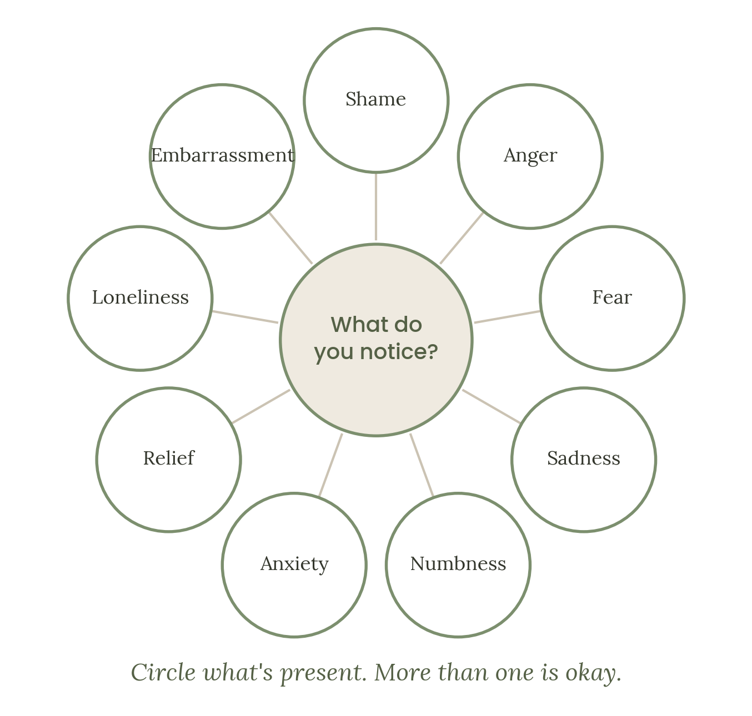
TAKE IT WITH YOU
This week, notice the physical sensation that shows up just before your inner critic speaks. You don't need to change it yet. Just notice it arriving, the way you'd notice weather.

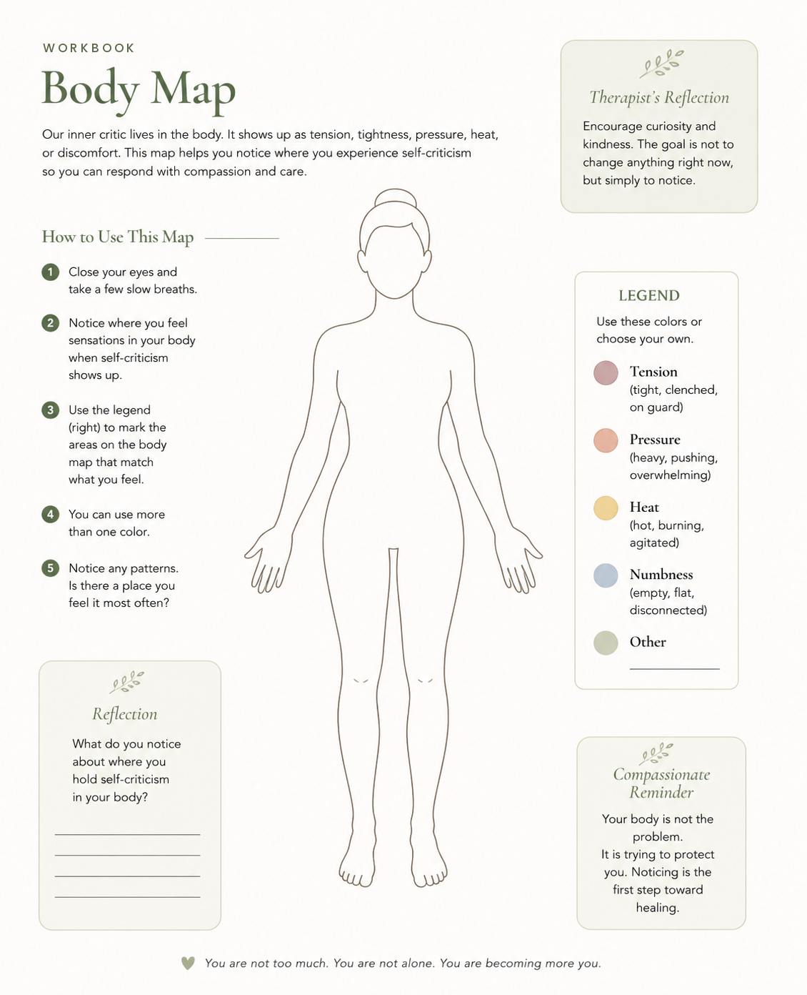

CHAPTER 5

Another Voice Is Possible

We've spent four chapters getting to know this part of you more closely — its words, its intentions, its origins, and the way it moves through your body. Now I want to introduce a different question: what else is possible, alongside this voice?
I want to be careful with language here, because “another voice” can sound like a replacement, as if the goal is to swap a mean internal narrator for a nicer one and call it done. That's not quite it. The goal is closer to addition than replacement. The critical part doesn't necessarily need to disappear for a more compassionate part to have room to speak. In fact, trying to forcefully silence the critic often backfires, the same way telling yourself not to think about something tends to bring it more clearly into focus. What tends to work better is building a second voice strong enough to stand alongside the first — not to shout it down, but to offer another perspective in the room.
This is where self-compassion research becomes useful, particularly the framework developed by researcher Kristin Neff, who describes self-compassion as resting on three components. The first is mindfulness — noticing your pain clearly, without exaggerating it and without pushing it away. The second is common humanity — recognizing that struggle, failure, and imperfection are part of being human, not evidence of unique personal defect. The third is self-kindness — offering yourself the same warmth you might offer someone you love, rather than the harshness you might reserve only for yourself.
A useful test, one I return to often with clients: imagine someone you deeply love came to you having just gone through your exact situation. Picture them clearly. What would you actually say to them? Most people, without much effort, can access real warmth and perspective for someone else in this position. They'd notice the context, the pressure that person was under, the fact that one moment doesn't define someone's whole character. This isn't a trick or a fantasy — it's evidence that the capacity for compassion already exists in you. It's simply been trained to flow outward far more easily than it flows inward.
So it's worth asking honestly: what makes it harder to offer yourself those same words? For many people, the answer involves a fear that self-kindness is really just self-indulgence in disguise — that if they stop being hard on themselves, they'll stop trying altogether. The research doesn't support that fear. Self-compassion is consistently associated with greater motivation and resilience after setbacks, not less, in part because people who aren't consumed by shame have more energy available for actually addressing the problem in front of them, rather than defending against how bad they feel about it.

THERAPIST'S REFLECTION
I ask almost every client some version of, “What would you say to a friend?” — and I've noticed something over the years. People rarely need help finding the compassionate words. They need help believing they're allowed to say those words to themselves. That belief, more than the words themselves, is usually the real work.

RESEARCH SNAPSHOT
Kristin Neff's research identifies mindfulness, common humanity, and self-kindness as the three interconnected components of self-compassion. Across numerous studies, higher self-compassion correlates with lower anxiety and depression and greater emotional resilience, and — contrary to a common fear — does not correlate with reduced motivation or lowered standards. If anything, people high in self-compassion tend to take more ownership of mistakes, precisely because doing so feels less catastrophic.

WORKBOOK
ANOTHER VOICE IS POSSIBLE
1 Picture someone you deeply love in your exact situation.
What would you say to them? Write it as if speaking directly to them.

2 Now read what you wrote as if it were meant for you.
What do you notice?

3 What makes it difficult to offer yourself those same words?
Circle any that fit.
Feels indulgent · Feels untrue · Feels unfamiliar · Afraid I'll stop trying · Don't feel deserving
4 Common humanity check:
Is there anyone else, anywhere, who has ever felt this same way in a similar moment?
☐ Yes, definitely ☐ Probably ☐ Hard to imagine right now
5 Try writing one sentence of self-kindness in your own natural voice.
Not a script — just something true and gentle.

6 Rate how believable that sentence felt as you wrote it.
Not believable at all 1 — 2 — 3 — 4 — 5 Fully believable
PAUSE & REFLECT
It's common for the kind voice to feel thinner or less convincing than the critical one, especially at first. That's not a sign you're doing this wrong. Voices that have had years of practice tend to sound more confident than voices still finding their footing.
TAKE IT WITH YOU
This week, when you notice the critic, try adding rather than replacing: “That's one part of me talking. What might another part say?” You don't have to fully believe the second voice yet. You just have to let it speak.

CHAPTER 6

Carrying It Forward

At the start of this workbook, I asked you to bring one situation to mind — something recent, something specific, a moment you were especially hard on yourself. You've now looked at that same moment through several different lenses: as a message from a protective part, as a strategy with a history, as a sensation in your body, as an opening for a different kind of voice. Nothing about the original event has changed. But I'd guess your relationship to it has shifted at least a little, even if it's subtle.
This final chapter isn't about arriving at some permanent resolution. Inner critics don't tend to disappear because you've understood them well; they tend to soften, gradually, through repeated small moments of being met differently than they expect. The goal from here isn't to complete some final exercise that ends the relationship with this part of you. It's to keep practicing the kind of attention you've built across these pages — noticing the voice, getting curious about its intention, feeling what's happening in your body, and letting a second, kinder voice take up a little more room each time.
I want to say something about pacing, because this matters more than people expect. Parts of us that have been protecting against pain for years, sometimes decades, don't relax quickly just because they've been understood once. If the critic gets louder in the days after doing this kind of reflection, that's not evidence that the work failed. It can actually mean the opposite — a part that has been in charge for a long time may momentarily push harder when it senses things shifting, the same way any system resists a change to its equilibrium, even a change toward something better. This tends to pass. It rarely means starting over from nothing.
It's also worth being honest about the limits of a workbook. What you've done here is real, and it can meaningfully shift how you relate to this part of yourself. But some inner critics are tied to deeper wounds — earlier trauma, complicated family dynamics, patterns that took a long time to form and may take real relational work to shift. If what came up for you here felt like more than you can hold alone, that's not a sign you did the workbook wrong. It's a sign this might be a good moment to bring a therapist into the process, someone who can go at the pace your whole system, not just your thinking mind, actually needs.
For now, I want to close by asking you to return one more time to where we started.

THERAPIST'S REFLECTION
Near the end of therapy, I sometimes ask clients to look back at where we began. Almost no one describes their situation as having disappeared. What they describe, instead, is more room around it — more choice in how to respond, less certainty that the critic's version is the only true one. That's usually what change actually looks like. Less dramatic than people expect, and more durable because of it.

RESEARCH SNAPSHOT
Longitudinal research on self-compassion interventions suggests that meaningful shifts in self-relating tend to develop gradually, through repeated practice, rather than through a single insight. Consistent with this, studies on habit and neural change indicate that new patterns of internal relating are built through repetition over time — which is why brief, sustainable practices matter more, in the long run, than any one intensive exercise.

WORKBOOK
CARRYING IT FORWARD
1 Return to the original situation, one final time.
What has changed about your understanding of it, if anything?

2 Which idea from this workbook felt most true or useful to you?
Circle one, or write your own.
This is a protective part · It learned its job somewhere · My body knows before my mind does · A kinder voice is possible · Change is gradual
3 What would you like to remember about this part, going forward?

4 What's one small, sustainable practice you could return to when the critic shows up?
☐ Naming it (“There it is”) ☐ Asking what it's afraid of ☐ Grounding through breath or the senses ☐ Asking what I'd say to someone I love
5 Rate how supported you'd feel trying this practice on your own, right now.
Not very 1 — 2 — 3 — 4 — 5 Quite supported
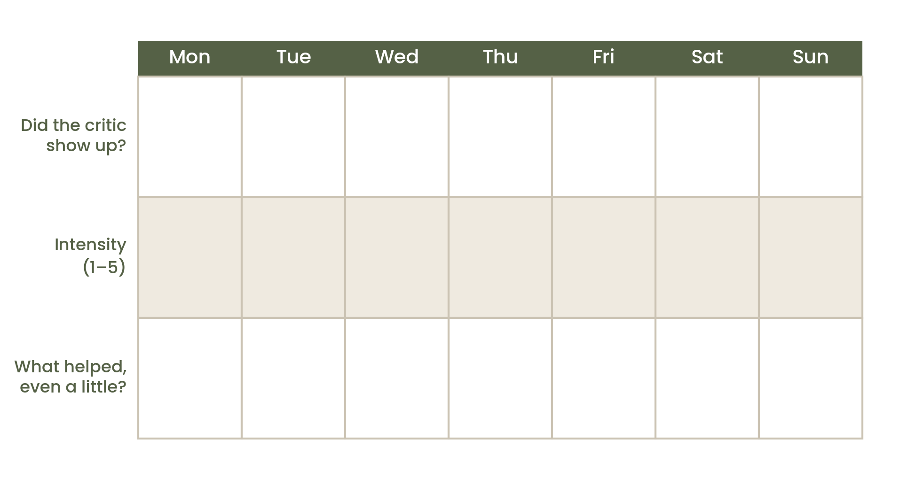
TAKE IT WITH YOU
Choose one sentence from this entire workbook — a therapist's reflection, something you wrote yourself, anything that stayed with you — and carry it with you this week, the way you might carry a note from a good session into an ordinary Tuesday.

CLOSING

Final Reflection

If you've made it here, you've spent real time with something that isn't easy to look at directly. That matters, and I don't want it to pass without acknowledgment.
Understanding your inner critic doesn't mean it goes quiet overnight, and it doesn't mean every hard moment ahead will feel resolved by what you've done in these pages. What it does mean, I hope, is that the next time this voice shows up, you'll have a slightly wider view of it — not just what it says, but what it's protecting, where it learned its job, how it moves through your body, and what other voice might be available alongside it.
That wider view is not nothing. It's often exactly where lasting change begins — not with silencing a part of yourself, but with finally being willing to sit down across from it and ask what it's been so afraid of, for so long.
Be gentle with yourself this week. You've done more here than it might feel like.

Dr. Barbie Hessel, LCSW, SEP, CPATP, SP
Founder and Psychotherapist
SIMPLY BEING THERAPY

CLOSING

Resources

If this workbook brought up more than you expected, or if you'd like ongoing support working with these patterns, consider reaching out to a licensed therapist in your area. A therapist trained in Internal Family Systems, somatic approaches, or self-compassion-focused modalities may be especially well suited to this kind of work, though any therapist you trust is a reasonable place to start.
IF YOU NEED SUPPORT NOW
If you are in the United States and experiencing a mental health crisis, you can call or text 988 to reach the Suicide & Crisis Lifeline, available 24/7.

To learn more about the ideas referenced in this workbook, you may want to explore:

– Richard Schwartz — Internal Family Systems
– Kristin Neff — self-compassion research
– Bessel van der Kolk, Peter Levine, and Pat Ogden — somatic approaches to psychotherapy

This workbook is an original, independent resource and not an official product of any of these frameworks.

READY TO TALK TO SOMEONE?
If working through this stirred up more than you expected, or you're simply ready for support putting it into practice, Simply Being Therapy offers free consultations for new clients. Reach out at simplybeingtherapy.com or call 615-601-1182 — we'd be glad to talk.

SIMPLY BEING THERAPY
simplybeingtherapy.com

